**Overview**

Sed ut perspiciatis unde omnis iste natus error sit voluptatem accusantium doloremque laudantium, totam rem aperiam, eaque ipsa quae ab illo inventore veritatis et quasi architecto beatae vitae dicta sunt explicabo. Nemo enim ipsam voluptatem quia voluptas sit aspernatur aut odit aut fugit, sed quia consequuntur magni dolores eos qui ratione voluptatem sequi nesciunt. Neque porro quisquam est, qui dolorem ipsum quia dolor sit amet, consectetur, adipisci velit, sed quia non numquam eius modi tempora incidunt ut labore et dolore magnam aliquam quaerat voluptatem.

**Why ESG.ETF?**

1. Lorem ipsum dolor sit amet, consectetur adipiscing elit.
2. Sed do eiusmod tempor incididunt ut labore et dolore magna aliqua.
3. Duis aute irure dolor in reprehenderit in voluptate velit esse cillum dolore eu fugiat nulla pariatur.

**ESG**

Lorem ipsum dolor sit amet, consectetur adipiscing elit, sed do eiusmod tempor incididunt ut labore et dolore magna aliqua. Ut enim ad minim veniam, quis nostrud exercitation ullamco laboris nisi ut aliquip ex ea commodo consequat.

**Key Facts**

|  |  |
| --- | --- |
| Inception Date | December 01, 2013 |
| Benchmark | MSCI USA Small Cap Extended ESG Focus Net Return Index |
| Total Costs | 0.10% |
| Net Assets |  |
| Exchange | XETRA |

**About the Manager**

Lorem ipsum dolor sit amet, consectetur adipiscing elit, sed do eiusmod tempor incididunt ut labore et dolore magna aliqua. Ut enim ad minim veniam, quis nostrud exercitation ullamco laboris nisi ut aliquip ex ea commodo consequat.

**Performance**

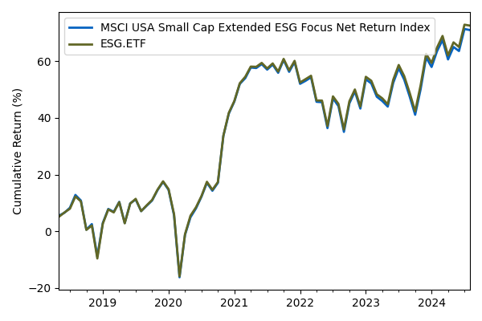

|  |  |  |  |  |
| --- | --- | --- | --- | --- |
|  | **1yr** | **3yr** | **5yr** | **10yr** |
| Return | 16.73% | 2.24% | 10.93% | N/A |

**Top Ten Holdings**

|  |  |  |
| --- | --- | --- |
| Ticker | Name | Weight |
| AAPL | Apple Inc. | 6.0% |
| MSFT | Microsoft Corporation | 5.0% |
| AMZN | Amazon.com Inc. | 4.0% |
| FB | Facebook Inc. | 3.0% |
| GOOGL | Alphabet Inc. | 2.0% |
| GOOG | Alphabet Inc. | 2.0% |
| BRK.B | Berkshire Hathaway Inc. | 2.0% |
| TSLA | Tesla Inc. | 2.0% |
| JNJ | Johnson & Johnson | 2.0% |
| JPM | JPMorgan Chase & Co. | 2.0% |

**Past performance is not indicative of future results. The performance data quoted represents past performance and current returns may be lower or higher. Investment return and principal value will fluctuate, so that shares, when redeemed, may be worth more or less than their original cost.**